PoC Assembly - TopCoder NodeJS Contests REST API Part 2
Deployment Guide

Revision History
Author | Revision Number | Date
TCSASSEMBLER | 1.0 | 2012/12/29

Deployment Instructions 3
1. Organization of Submission 3
2. Application Setup 3
3. Configurations 4
4. Deployment Instructions 4
5. Verification 5
6. Resource Contact List 5

Deployment Instructions

Organization of Submission
The folder structure:
Name | Description
codes/ | Source codes of this assembly
profile_example.txt | The context needs to be added into your profile file, such as .profile or .bash_profile (depends on the shell you are using) under your home folder.
sqlhosts.informixoltp_tcp | Need to copy to “Informix client SDK’s installation folder/etc”, for example: /opt/IBM/Informix/etc/
Deployment Guide.doc | The deployment guide document.
procedures.sql | SQL Stored procedures to run on the INFORMIX db.
codes/static/crud.html | Html test page to test the crud
!!!README!!!.txt | All the notes that need to be read and taken into consideration together with DG.
testdata.sql | SQL statements to run on the INFORMIX db after running procedures.sql and which can be used to perform CRUD opearations.

Here is the console look of all the files :

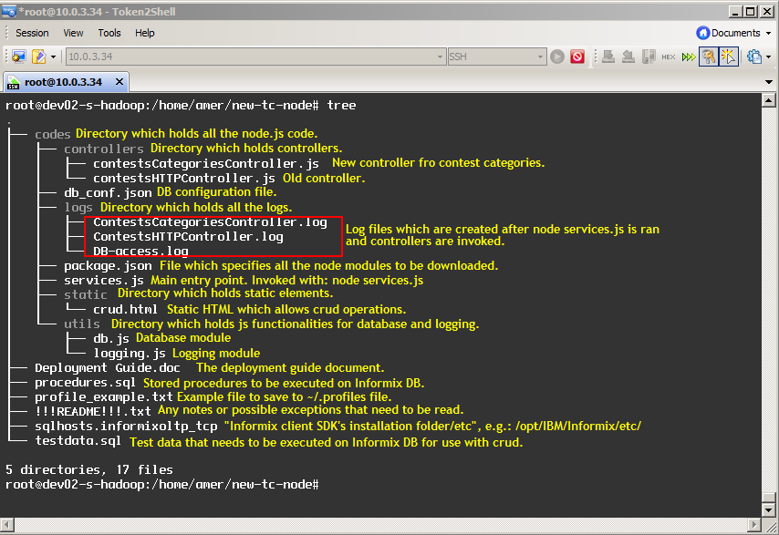

Application Setup
Preconditions:
- Linux System, such as Ubuntu (12.04) with development tool, such as g++, maker.
- Informix Client SDK (used to connect remote Informix Server)
- NodeJS 0.6.18 http://nodejs.org/ - http://nodejs.org/dist/v0.6.18/node-v0.6.18.tar.gz
- Express 3.0.0 http://expressjs.com/
- NodeJS-DB-Informix https://github.com/amitkr/nodejs-db-informix

Configurations
codes\db_conf.json

{
"host": "107.21.166.16", -- Informix Server IP
"user": "informix", -- User Name
"password": "1nf0rm1x", -- Password
"port": 2021, -- Database Port
"database": "tcs_catalog" -- Database Name
}

codes\getContestById.sql and codes\getContestTypes.sql are the SQL statements used in the assembly.

Deployment Instructions
  - Install NodeJS from http://nodejs.org/.
Please refer https://github.com/joyent/node/wiki/Installation about how to install NodeJS. In general, for *nux OS
wget http://nodejs.org/dist/v0.6.18/node-v0.6.18.tar.gz
tar -zxf node-v0.6.18.tar.gz
cd node-v0.6.18
./configure
Make
sudo make install
  - Install Informix Client SDK. It can be downloaded from http://www14.software.ibm.com/webapp/download/search.jsp?rs=ifxdl and please choose the right version for you. For example http://www14.software.ibm.com/webapp/download/preconfig.jsp?id=2012-06-11+02%3A03%3A50.913225R&S_TACT=&S_CMP= is for x86 Linux system.
After you download and unpack the package, please refer to its installation guide at doc/Client_install_guide.pdf to install.
  - Extract the package.
  - Copy sqlhosts.informixoltp_tcp “Informix client SDK’s installation folder/etc”, for example: /opt/IBM/Informix/etc/, open it with any editor and you can change the Informix Server’s IP and Port.
informixoltp_tcp onsoctcp 107.21.166.16 2021
  - Open your shell profile (for example, if you are using C shell, the file name should be .profile under your home folder) and add the content of profile_example.txt to your file. Change the INFORMIXDIR according to your system. And reboot the system or run the profile to make sure the settings effective.
INFORMIXDIR='/opt/IBM/informix'
  - Go to codes folder, run npm install.
  - Open db_conf.json and you can modify the database connection parameter if necessary. [NOTE] NodeJS-DB-Informix reads the host and port information from Informix Client SDK’s configuration file instead of this file, but we leave it here to follow the test case of NodeJS-DB-Informix, they may change the implementation later.
  - Install Server Studio from this location: http://www.serverstudio.com/downloads.html, latest version is R.8.5
Go to File > New Connection
Use the following information to connect if you don’t have other VM to use:
server: informixoltp_tcp
host: 107.21.166.16
user: informix
password: 1nf0rm1x
port: 2021
database: tcs_catalog
table: project_category_lu
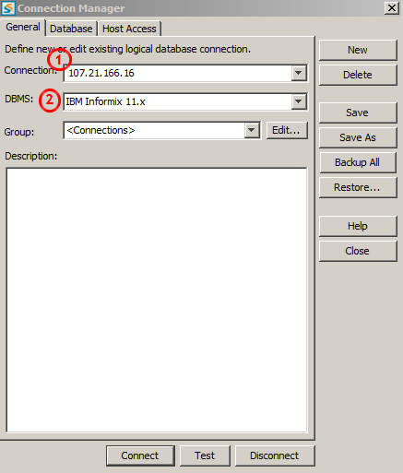
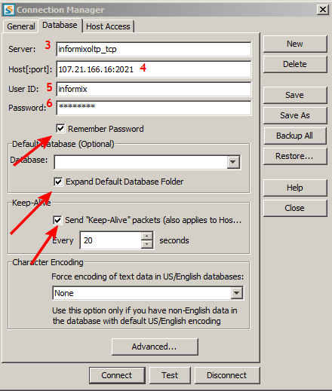
Clcik Test and then Connect.
Right click on the database, chose New > SQL Editor:
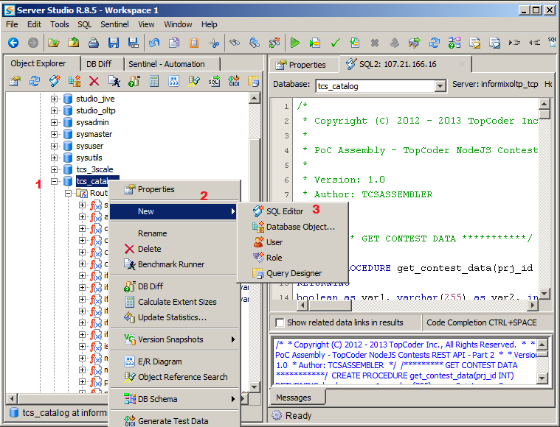
Copy everything from procedures.sql and execute it. This will create all the necessary stored procedures on the server.
After that copy everything from testdata.sql and execute it. This will create new records which have no foreign key constrictions and which can be easily updated, deleted, etc.

Verification
- For the old controller:

Under codes folder, run node services.js and you will see the http server is listening at 8080
Open browser to access
http://localhost:8080/contests/types

Open browser to access
http://localhost:8080/contests/id/30010007 < (this id exists).
http://localhost:8080/contests/id/30010008 < (this id exists).
http://localhost:8080/contests/id/30010003 < (this id does not exist).

- For the new controller:

Open browser to access:
http://localhost:8080/crud.html < Perform crud operations.

crud.html file will perform jquery ajax operations with GET, POST, PUT and DELETE – and this can be seen in the html itself. The successful requests will be appended to provided divs on the page itself and you will not be redirected nowehre.

After running, the log files will be present in: codes/logs/ directory under appropirate names.

Following must be taken into considaration:

  - – Insert and Update on certain times brake the node (0.6.18). The issue happens to be with the informix module itself. I’ve informed the creator of the informix module about this issue and he raised an issue on his module github page with the following error:
MI_LIB_USAGE: XIX000:-7520:Argument (client library error) is NULL.
Segmentation fault
https://github.com/amitkr/nodejs-db-informix/issues/5

I attached the dumpted core:

https://docs.google.com/file/d/0B3TYHdEDoVIbTTZrc3BXU04yV3c/edit

  - Select one:

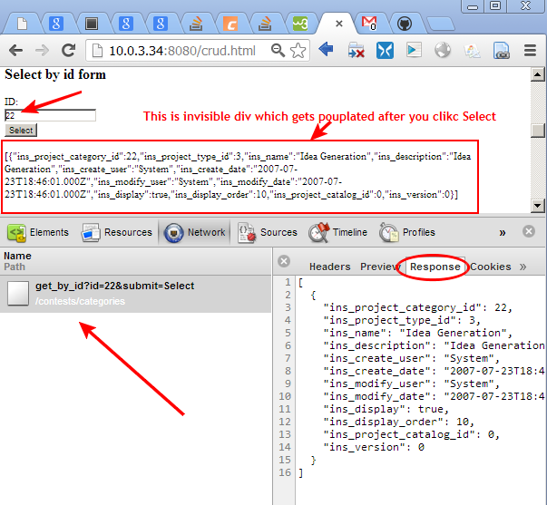

  - Select all:

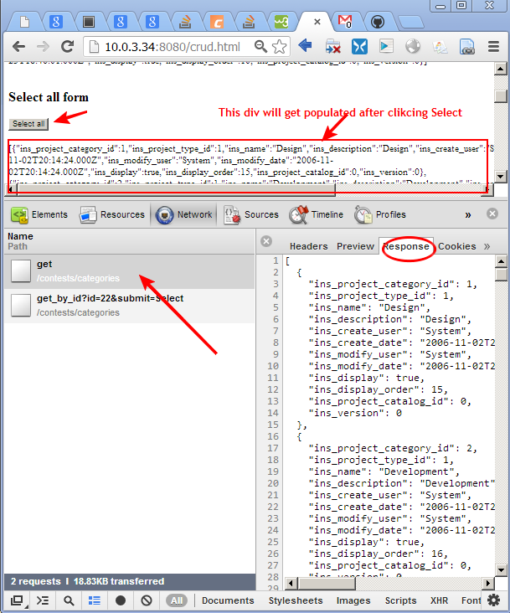

2.4 Insert gets broken but data is written do DB (this does not happen all the time – sometimes it passes):

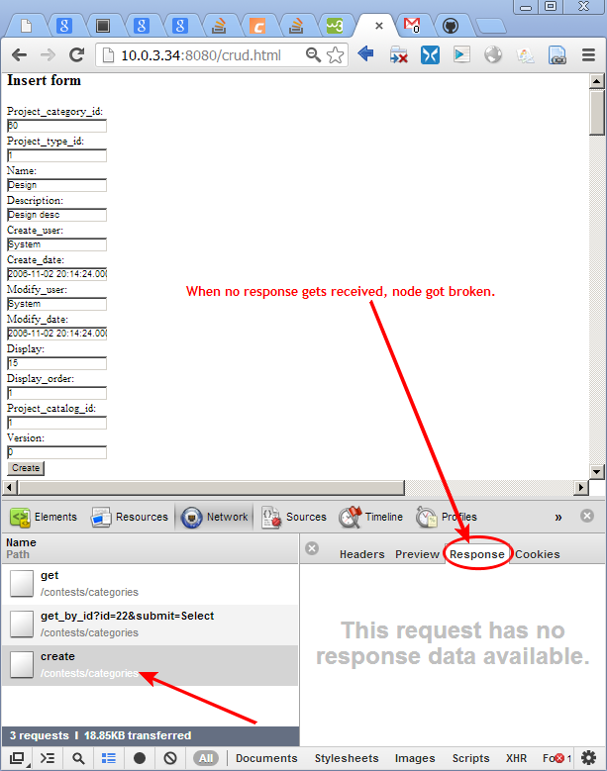

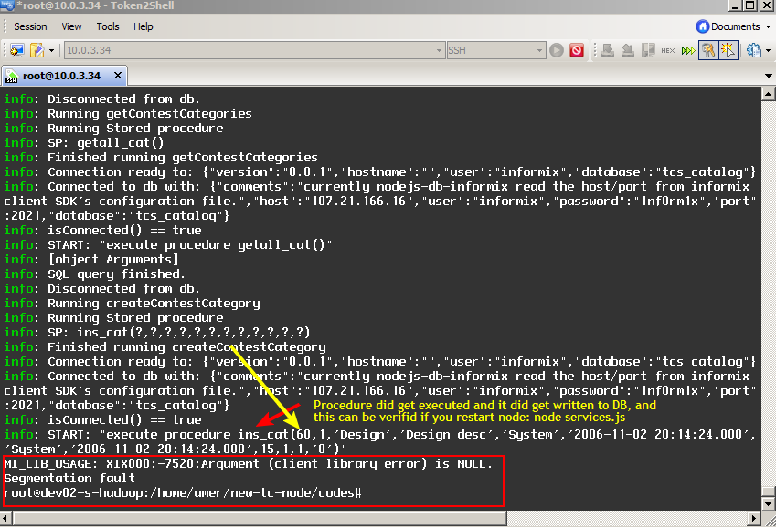

After we restart node by calling:

$ node servies.js

we can see that record did get inserted. Same thing happens with update. Record gets updated and node brakes.
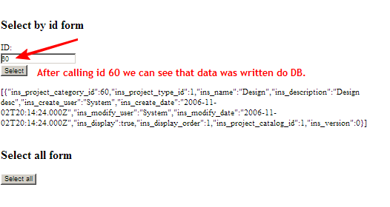

Resource Contact List
Name | Resource Email

